

Y.RISHITHA REDDY
192424233
AI&DS
CSA0315
DATA STRUCTURE

DATA STRUCTURE OBSERVATION

1.Matrix Multiplication

Aim
To write a C program to perform matrix multiplication.

Observation
Matrix multiplication of A[m][n] and B[n][p] gives C[m][p].

Algorithm
- Start.
- Read the dimensions and elements of matrix A and B.
- Check if multiplication is possible (columns of A = rows of B).
- Perform multiplication using triple nested loop.
- Store result in matrix C.
- Display the resultant matrix.
- Stop.

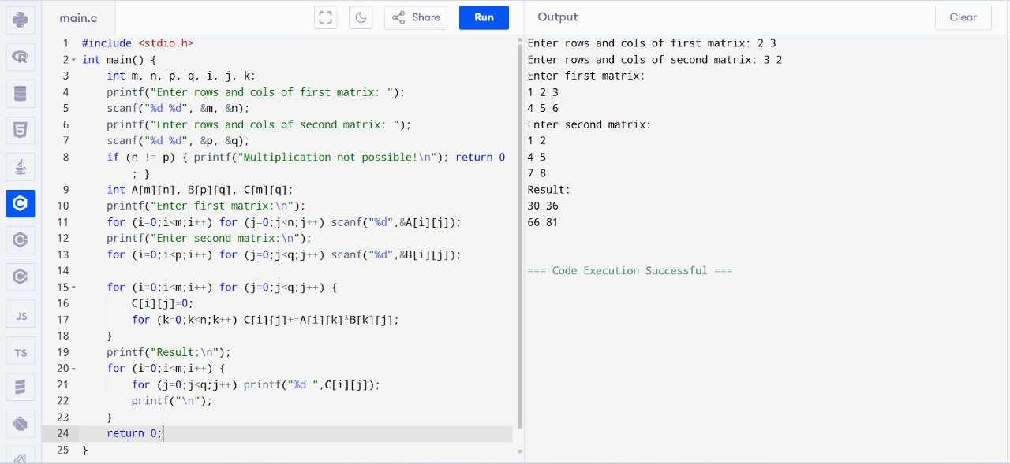

Result
The program was successfully executed and the product of two matrices was obtained.

2.Odd or Even Numbers

Aim
To write a C program to find odd or even numbers from a given set of numbers.

Observation
Odd numbers leave remainder 1 when divided by 2; even numbers leave remainder 0.

Algorithm
- Start.
- Read the number of elements.
- Read the set of numbers.
- Check each number using modulus operator %2.
- Print whether it is Odd or Even.
- Stop.

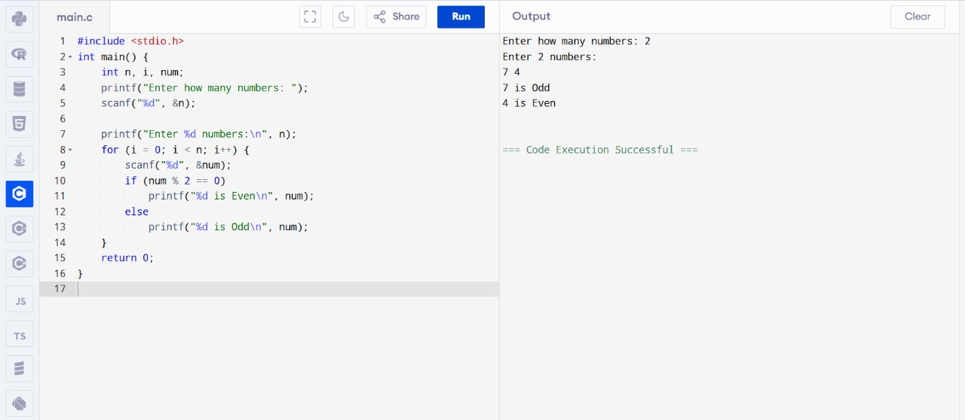

Result
The program was successfully executed and the given set was classified as odd or even.

3.Factorial without Recursion

Aim
To write a C program to find the factorial of a given number without using recursion.

Observation
Factorial n! = n × (n-1) × ... × 1.

Algorithm
- Start.
- Read integer number n.
- Initialize fact=1.
- Multiply fact by numbers from 1 to n.
- Print fact.
- Stop.

Result
The program was successfully executed and factorial was found without recursion.

4.Fibonacci without Recursion

Aim
To write a C program to print Fibonacci series without recursion.

Observation
Fibonacci sequence: 0,1,1,2,3,... where f(n)=f(n-1)+f(n-2).

Algorithm
- Start.
- Read number of terms n.
- Initialize first two terms 0 and 1.
- Use loop to compute next terms.
- Display series.
- Stop.

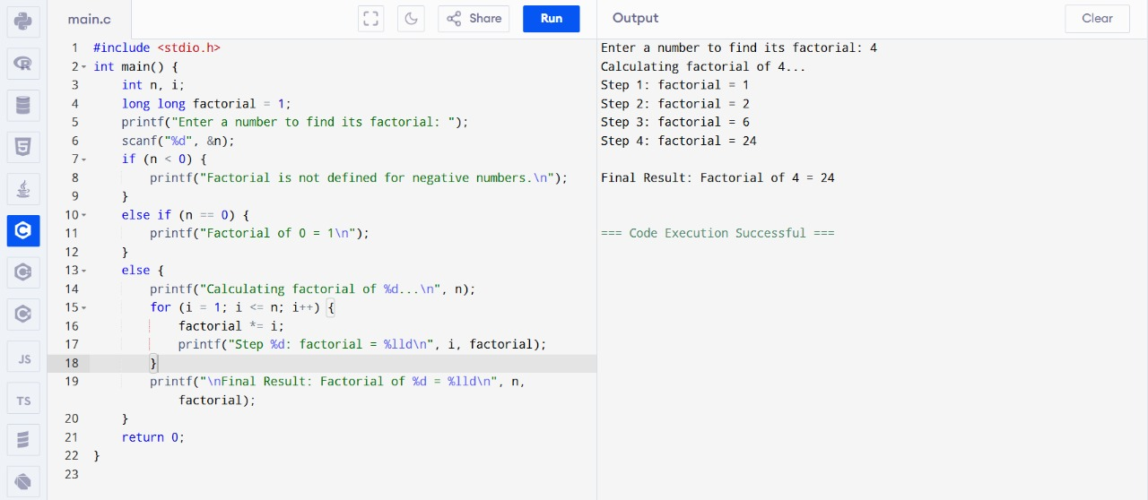

Result
The program was successfully executed and Fibonacci series was generated without recursion.

5.Factorial using Recursion

Aim
To write a C program to find the factorial of a given number using recursion.

Observation
Factorial of a number n is defined as n! = n × (n-1) × ... × 1.

Algorithm
- Start.
- Read integer number n.
- Define recursive function fact(n).
- If n==0 or n==1 return 1 else return n*fact(n-1).
- Call function and print result.
- Stop.

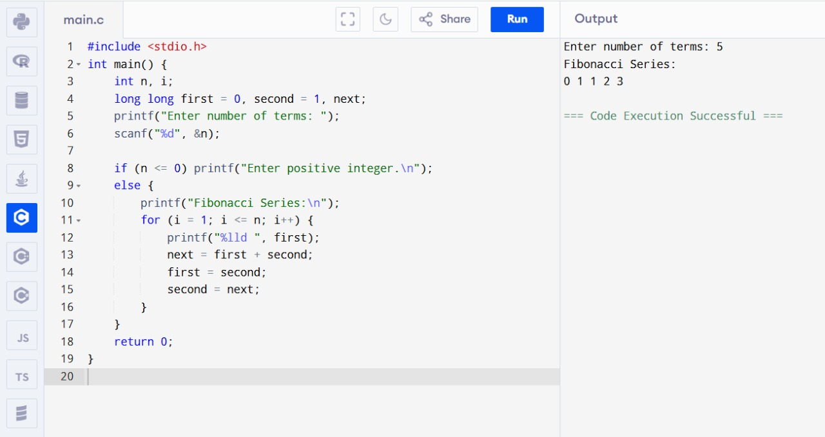

Result
The program was successfully executed and factorial was found using recursion.

6.Fibonacci using Recursion

Aim
To write a C program to print Fibonacci series using recursion.

Observation
Fibonacci sequence is generated using recursive relation f(n)=f(n-1)+f(n-2).

Algorithm
- Start.
- Read n.
- Define recursive function fib(n).
- If n==0 return 0, if n==1 return 1.
- Else return fib(n-1)+fib(n-2).
- Call function for first n terms.
- Display result.

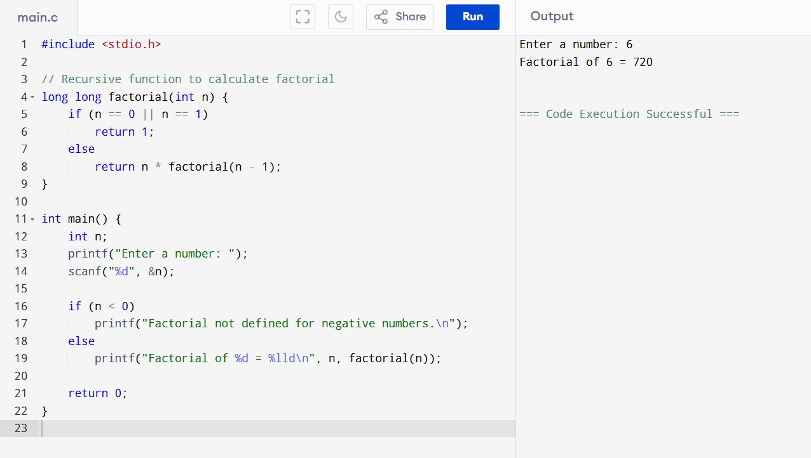

Result
The program was successfully executed and Fibonacci series was generated using recursion.

7.Array Operations (Insert, Delete, Display)

Aim
To write a C program to implement array operations such as insert, delete, and display.

Observation
Arrays are fixed-size collections. We can insert, delete and display elements using index-based operations.

Algorithm
- Start.
- Declare array and size.
- Insert element at given position.
- Delete element from given position.
- Display array elements.

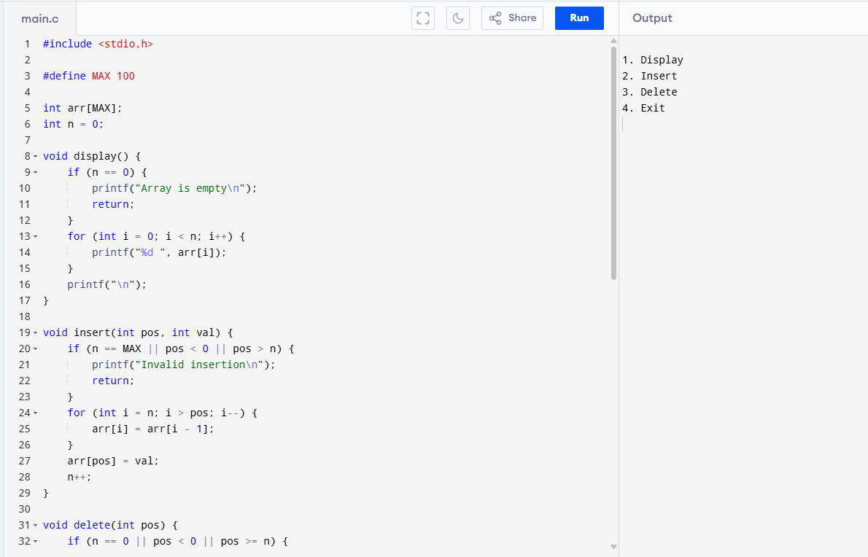

+

Result
The program was successfully executed and array operations were performed.

8.Linear Search

Aim
To write a C program to search a number using Linear Search method.

Observation
Linear search compares each element until key is found.

Algorithm
- Start.
- Read array elements and key.
- Scan array sequentially.
- If element matches key, print position.
- If not found, print not found.
- Stop.

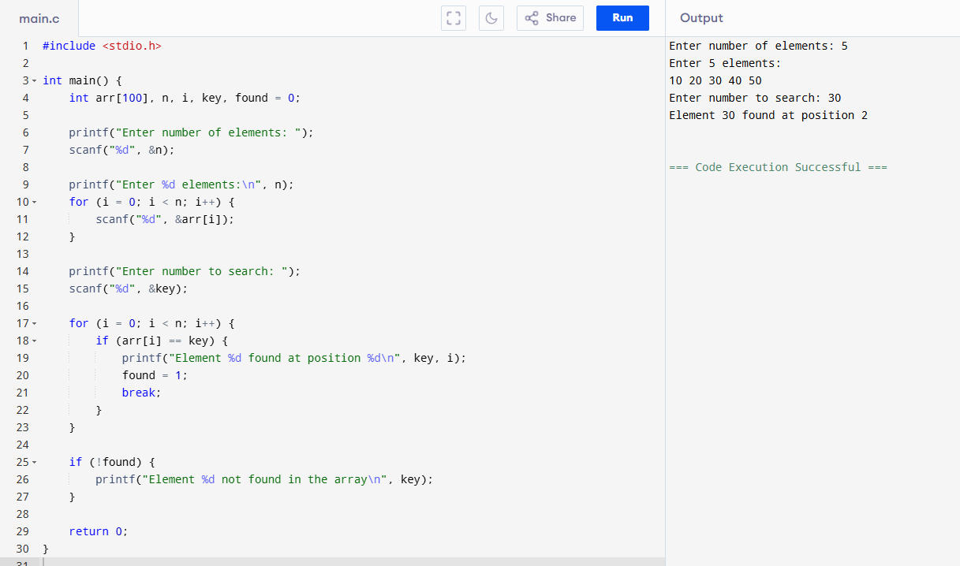

Result
The program was successfully executed and the element was searched using Linear Search.

9.Binary Search

Aim
To write a C program to search a number using Binary Search method.

Observation
Binary search works on sorted array by repeatedly dividing the search interval in half.

Algorithm
- Start.
- Read sorted array and key.
- Initialize low=0, high=n-1.
- While low<=high compute mid.
- If key==a[mid], found.
- Else if key<a[mid], high=mid-1 else low=mid+1.
- Stop.

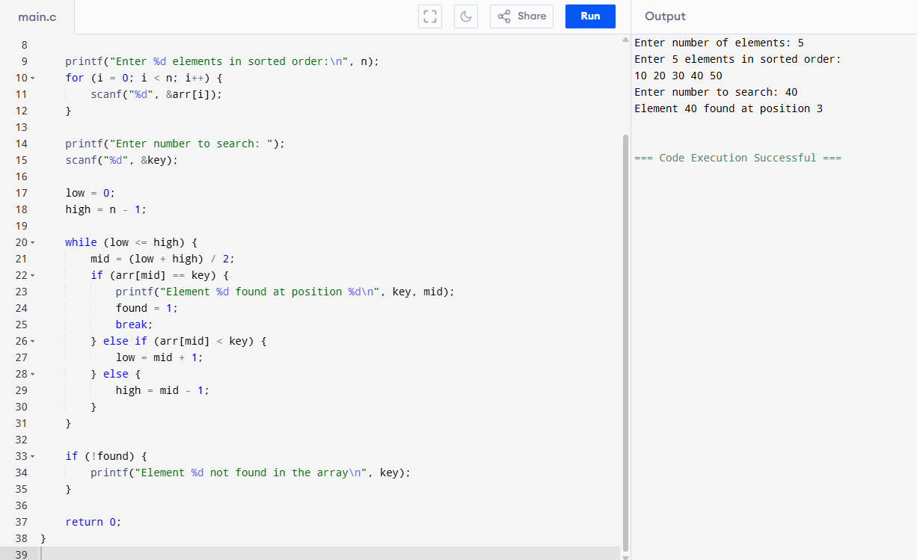

Result
The program was successfully executed and the element was searched using Binary Search.

10. Stack Operations (PUSH, POP, PEEK)
Aim: To implement stack operations using arrays.
Observation: The stack follows LIFO (Last In First Out) principle.
Algorithm:
- Initialize top = -1.
- For PUSH: increment top, insert element.
- For POP: remove element at top, decrement top.
- For PEEK: display element at top.

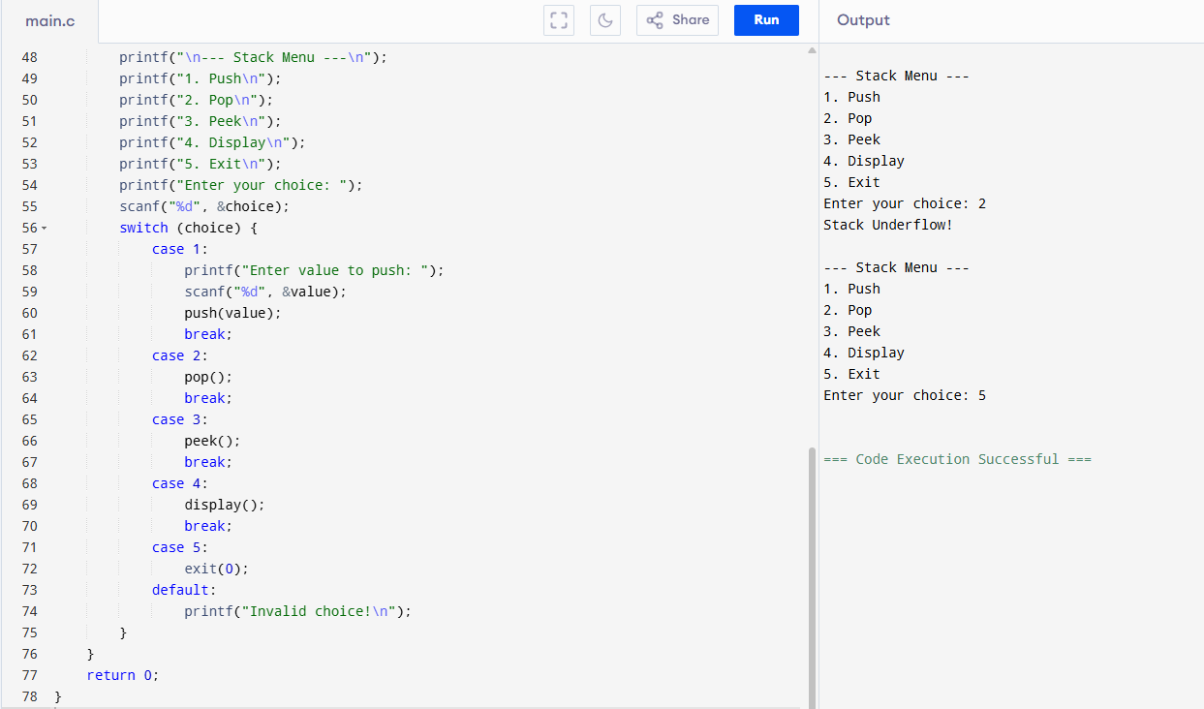

Result: Successfully implemented stack operations.

11.. Application of Stack (Notations)
Aim: To evaluate postfix/prefix expressions using stack.
Observation: Stack helps in expression evaluation.
Algorithm:
- Read expression from left to right.
- If operand, push onto stack.
- If operator, pop operands, evaluate, push result.
- At end, top of stack gives final answer.
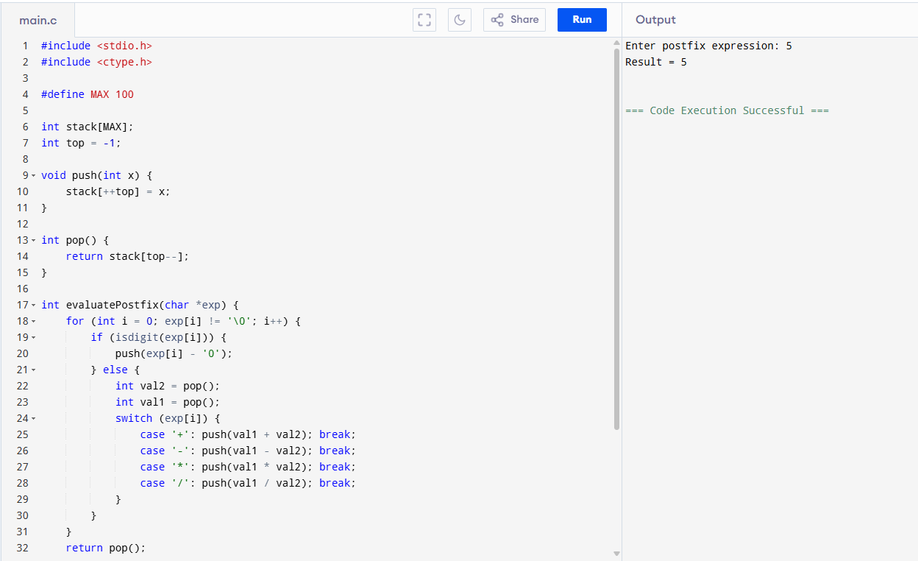

Result: Successfully evaluated expressions using stack.

12. Queue Operations (ENQUEUE, DEQUEUE, Display)
Aim: To implement queue operations using arrays.
Observation: Queue follows FIFO (First In First Out) principle.
Algorithm:
- Initialize front=0, rear=-1.
- ENQUEUE: Increment rear, insert element.
- DEQUEUE: Remove element at front, increment front.
- Display: Print elements between front and rear.
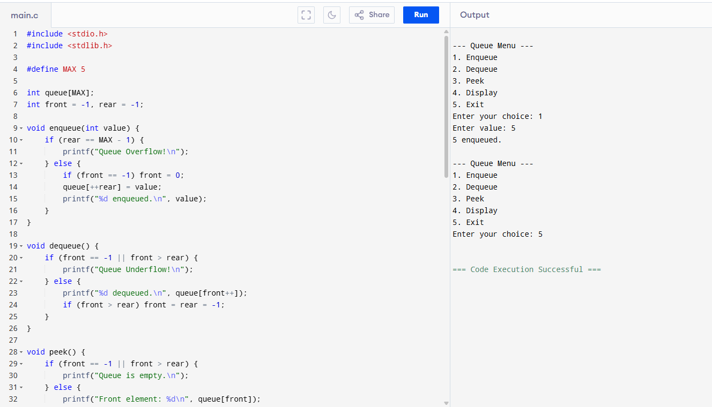

Result: Successfully implemented queue operations.

13. Tree Traversals (Inorder, Preorder, Postorder)
Aim: To implement different tree traversal techniques.
Observation: Different traversal orders produce different sequences.
Algorithm:
- Inorder (L, Root, R)
- Preorder (Root, L, R)
- Postorder (L, R, Root)
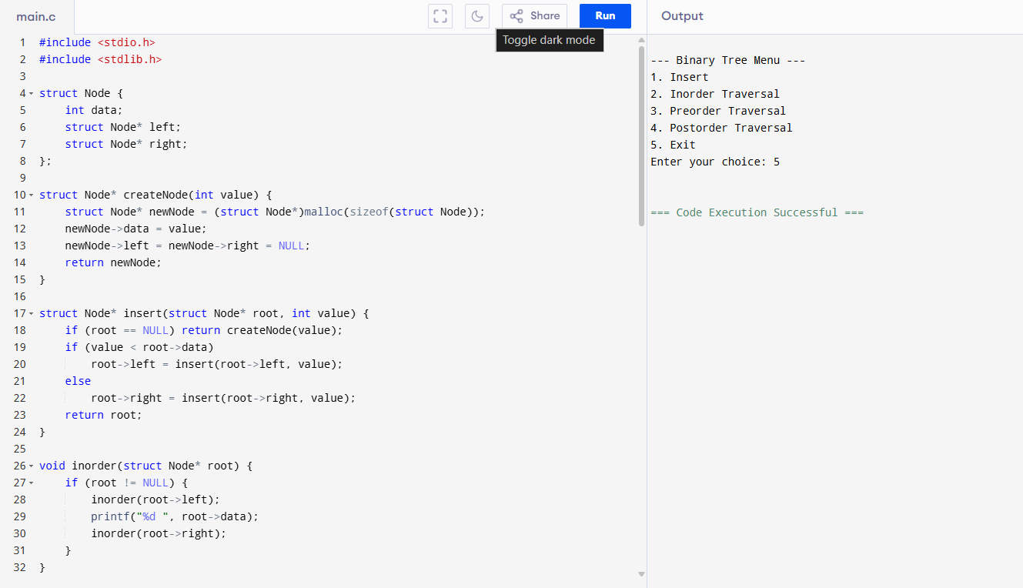

Result: Successfully performed tree traversals.

15. Hashing using Linear Probing
Aim: To implement hashing with linear probing.
Observation: Collisions are resolved by linear probing.
Algorithm:
- Compute hash = key % table_size.
- If slot empty, insert key.
- If occupied, move linearly until empty slot found.
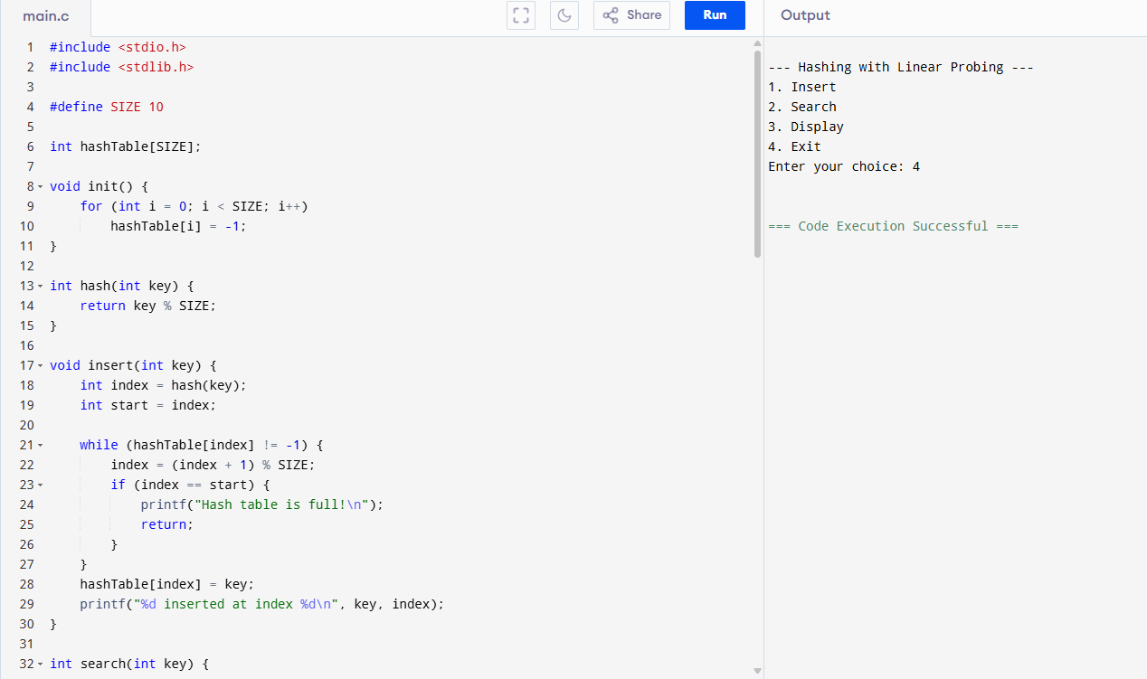

Result: Successfully implemented hashing with collision handling.

16. Insertion Sort
Aim: To sort a list using insertion sort.
Observation: Works well for small datasets.
Algorithm:
- Start from second element.
- Compare with previous elements.
- Insert into correct position by shifting.
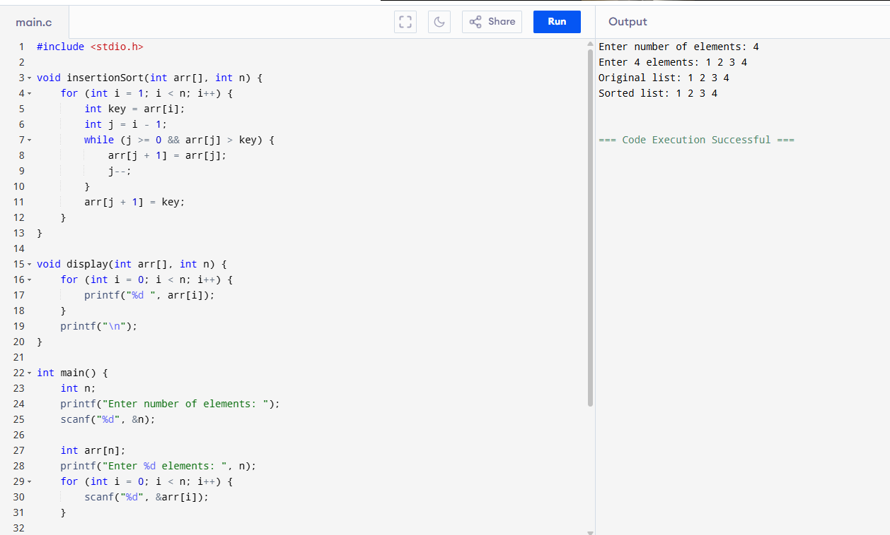

Result: Successfully sorted numbers using insertion sort.

17. Merge Sort
Aim: To sort numbers using merge sort
Observation: Efficient sorting using divide & conquer..
Algorithm:
- Divide array into halves recursively.
- Sort each half.
- Merge sorted halves.

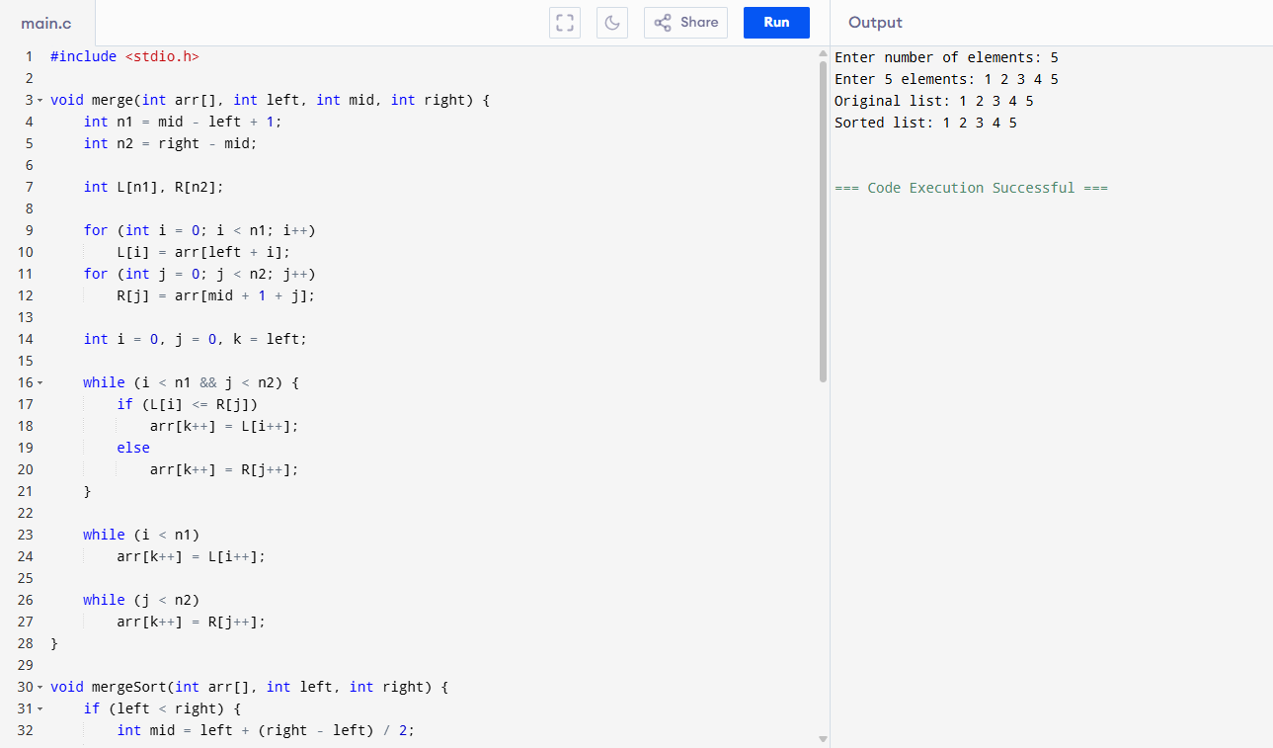

Result: Successfully sorted numbers using merge sort.

18. Quick Sort
Aim: To sort numbers using quick sort.
Observation: Works efficiently for large datasets.
Algorithm:
- Choose pivot element.
- Partition array into left < pivot, right > pivot.
- Recursively sort partitions.
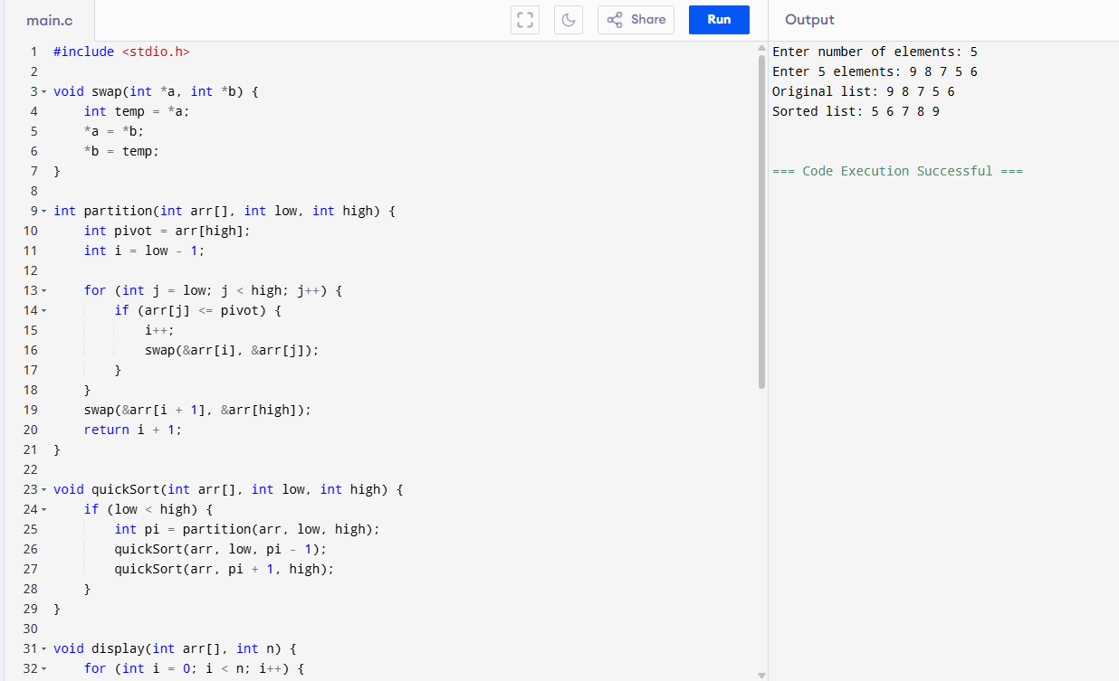

Result: Successfully sorted numbers using quick sort.

19. Heap Sort
Aim: To sort numbers using heap sort.
Observation: Sorting done using heap property.
Algorithm:
- Build max heap.
- Swap root with last element.
- Heapify remaining elements.
- Repeat until sorted.
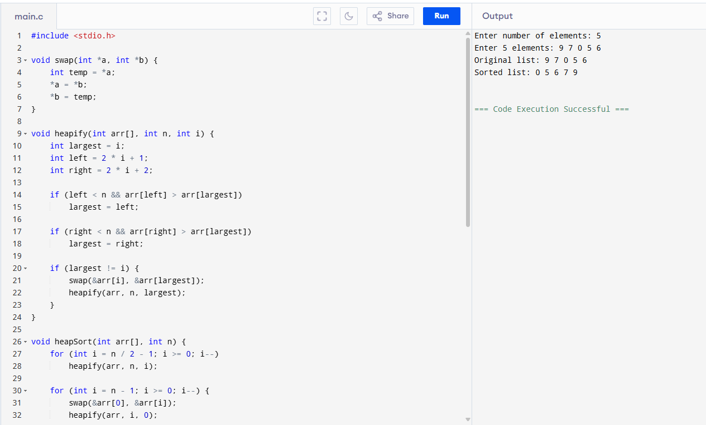

Result: Successfully sorted numbers using heap sort.

20. AVL Tree Operations (Insert, Delete, Search)
Aim: To implement insertion, deletion, and search in AVL tree.
Observation: Tree remains balanced.
Algorithm:
- Insert node like in BST.
- Update balance factor.
- If imbalance occurs, perform rotations.
- For delete, adjust and rebalance tree.
- For search, traverse based on key.
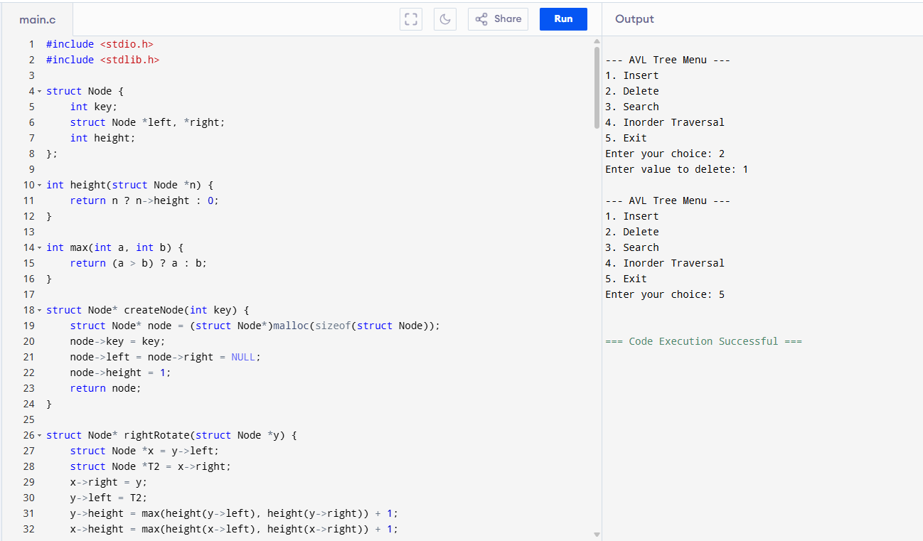

Result: Successfully implemented AVL tree operations.

21. Graph Traversal (BFS)
Aim: To traverse graph using Breadth First Search.
Observation: Visits nodes level by level.
Algorithm:
- Initialize queue.
- Visit source node, mark visited.
- Enqueue neighbors, dequeue front.
- Repeat until queue empty.
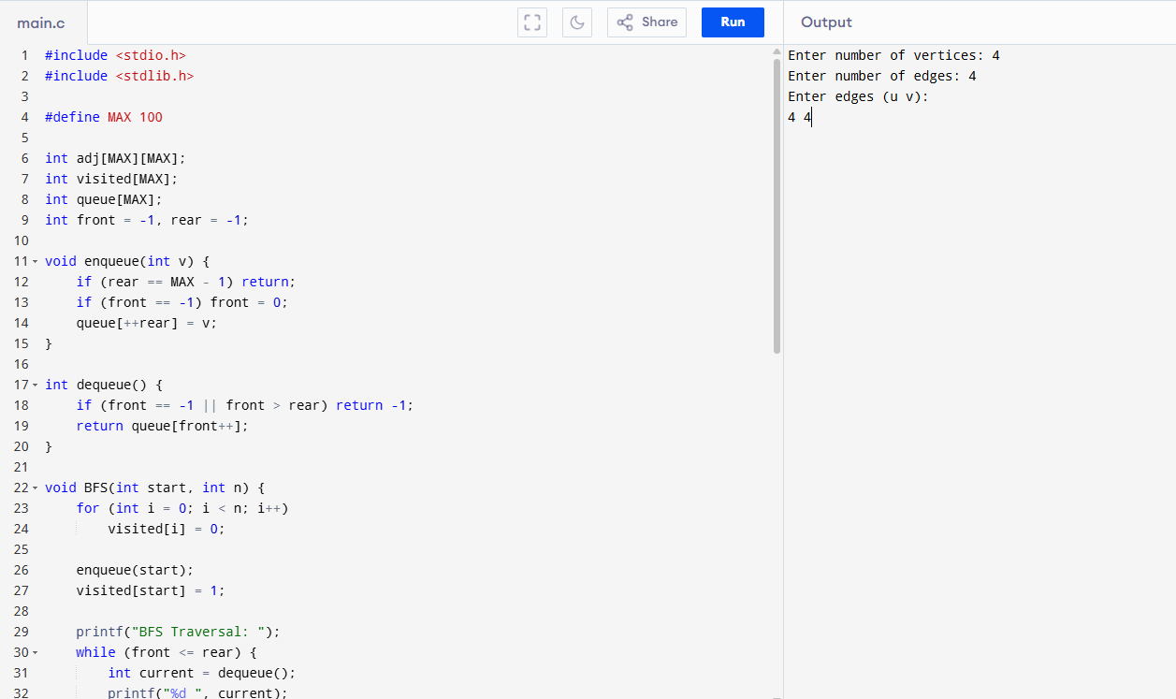

Result: Successfully traversed graph using BFS.

22. Graph Traversal (DFS)
Aim: To traverse graph using Depth First Search.
Observation: Traverses deeper before backtracking.
Algorithm:
- Use stack/recursion.
- Visit source node, mark visited.
- Recursively visit unvisited neighbors.
- Backtrack when no unvisited neighbor exists.
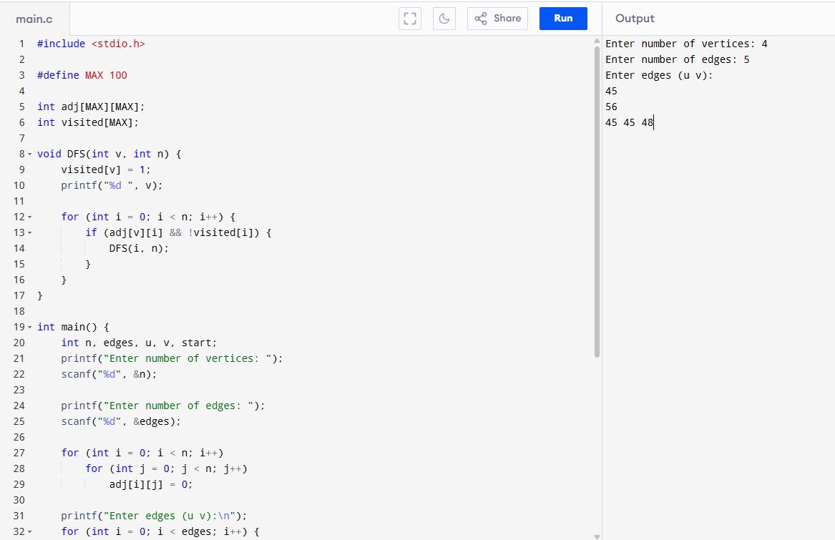

Result: Successfully traversed graph using DFS.

23. Dijkstra’s Algorithm (Shortest Path)
Aim: To find shortest path in weighted graph using Dijkstra’s algorithm.
Observation: Always finds shortest path in weighted graphs.
Algorithm:
- Initialize distance array.
- Start from source, set distance=0.
- Update neighbors with minimum distance.
- Mark visited nodes.
- Repeat until all nodes processed.
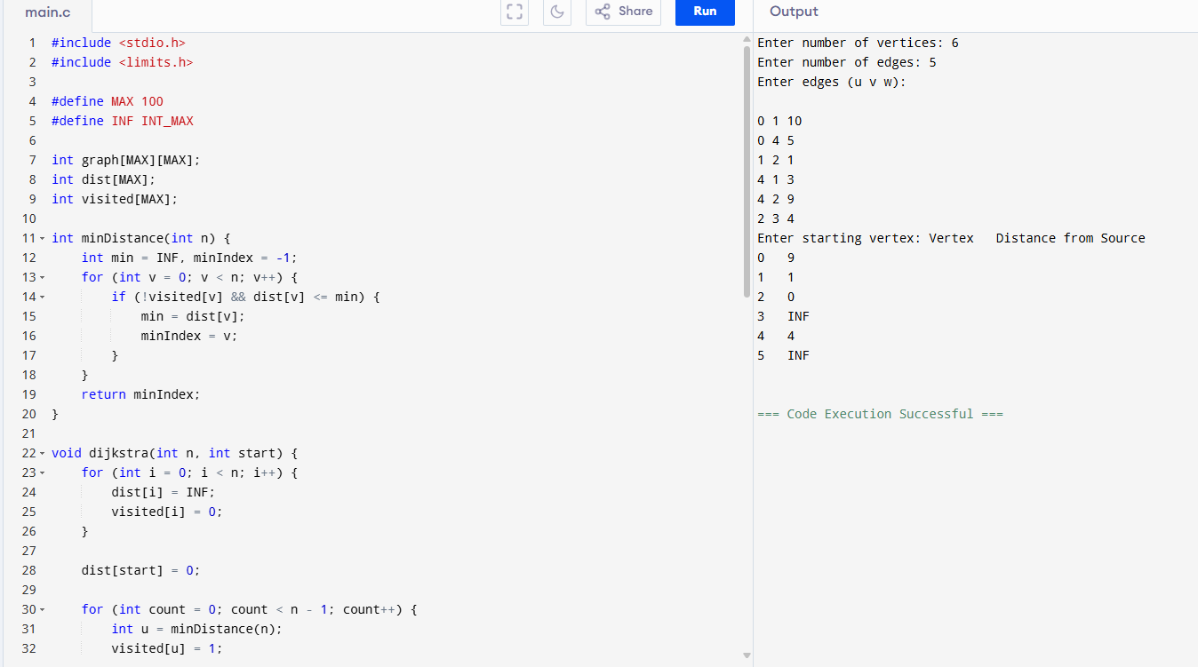

Result: Successfully implemented shortest path algorithm.

24. Prim’s Algorithm (MST)
Aim: To find minimum spanning tree using Prim’s algorithm.
Observation: Builds MST by adding one edge at a time.
Algorithm:
- Start from any node.
- Add smallest weight edge connecting to MST.
- Repeat until all vertices included
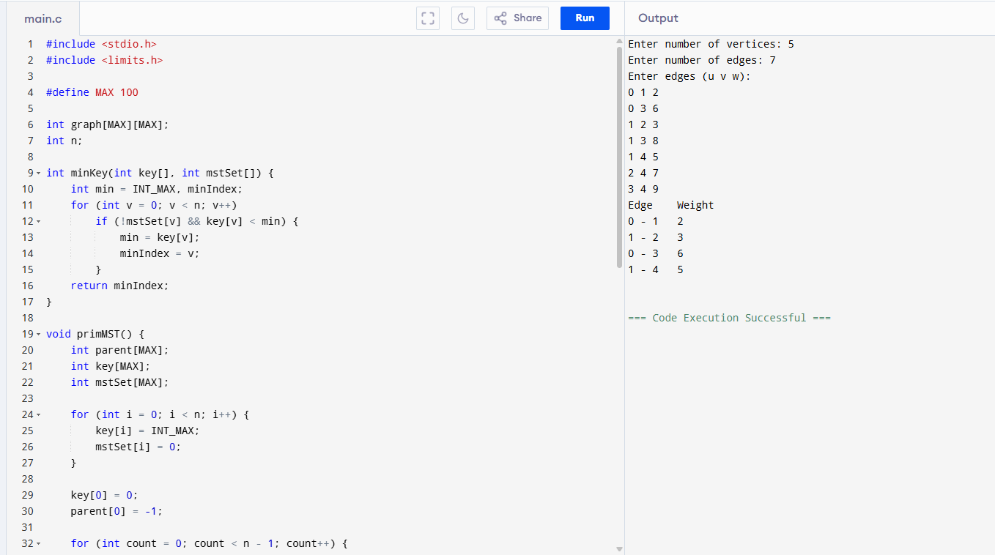

Result: Successfully found MST using Prim’s algorithm.

25. Kruskal’s Algorithm (MST)
Aim: To find minimum spanning tree using Kruskal’s algorithm.
Observation: MST built by adding edges in increasing weight order.
Algorithm:
- Sort edges by weight.
- Pick smallest edge, check cycle using union-find.
- If no cycle, add to MST.
- Repeat until MST complete.
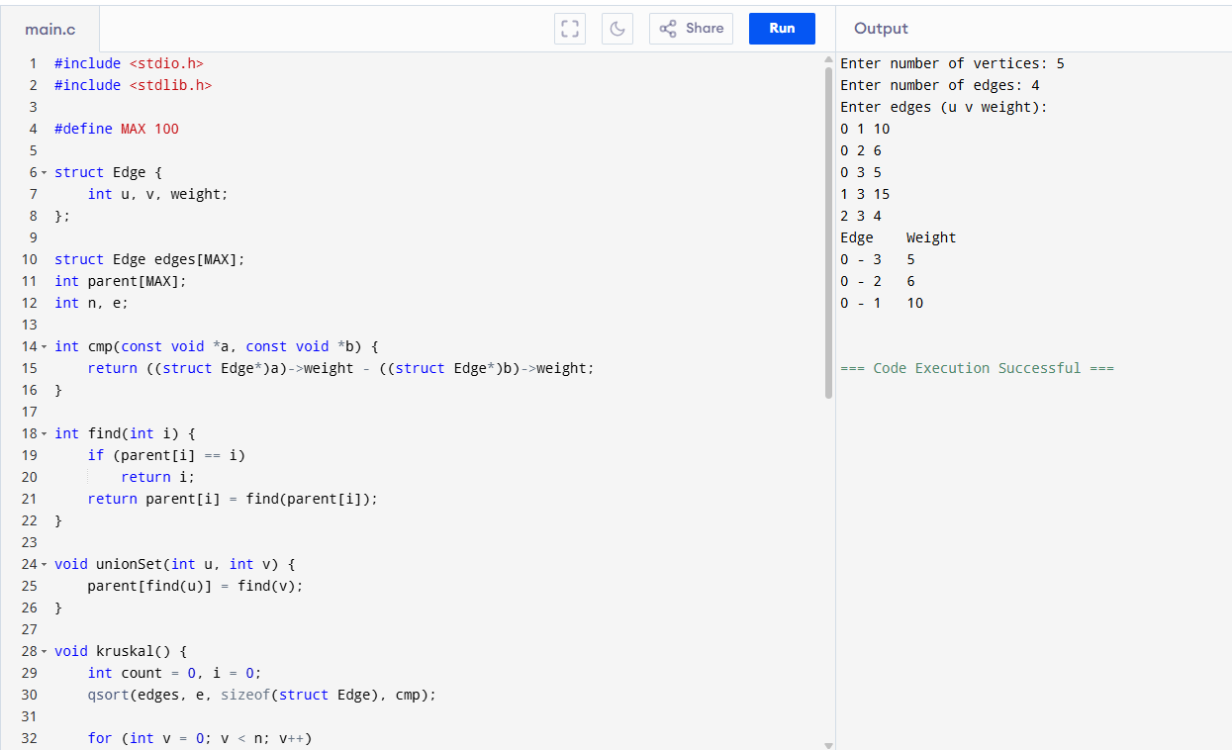

Result: Successfully found MST using Kruskal’s algorithm.

